**PROJECT WORKING SPACE**

For statement of work (SOW) and project timelines: [here](https://github.com/phamtaiece/Capstone-Sightline/blob/master/General%20Documents/SIGHTLINE_SOW%20(Final).docx)

**SLA Hardware Specification and Assembly**

**SLA – hardware:**

* 1500 OEM Rev E included:
* programmed SOM
* firmware 2.25.05 [FPGA ver. 10]
* 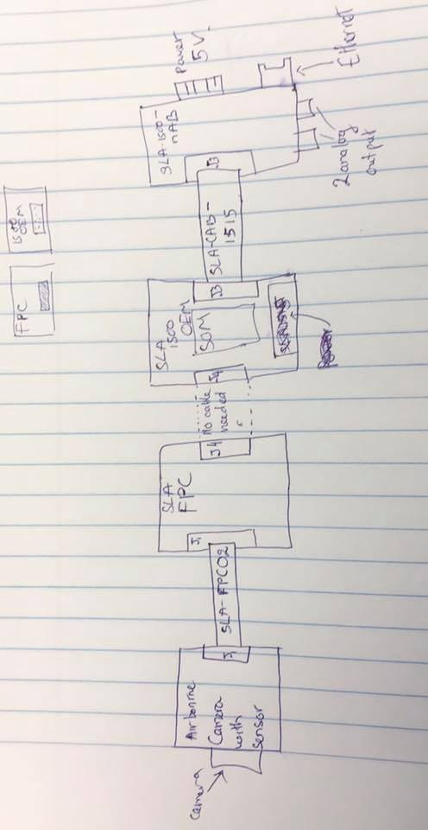license 0xFFFF
* heatsink on the top
* 1500 - SLA - nAB rev A
* 1500 - SLA-FPC Rev B
* SLA – 1500 – CASE
* Airborne camera (Mono camera) and sensor

**Assembly:**

The picture below is how pieces are connected together.

Fig 1. Basic assembly and connection

SLA-FPC 02: CABLE FFC 39 POS 0.3 MM 2” - part#: 150150239 -DigiKey

SLA-CAB-1515 – Specialize at Sightline (no part #)

J1: 39-POS, 0.3 MM – Molex – part #: 501912-3990

J4: part #: DF12B(5.0)-50DP-0.5V(86) [CONN header 50 POS 5MM SMD 0.5MM – Hirose] from 1500 OEM  
CONN RECEPT 50POS 0.5MM GOLD SMD DF12-50DS-0.5V(86) from 1500 – FPC.

J3: CONN header 14POS 1.25MM VRT SMD – Molex – Part# 53398-1471

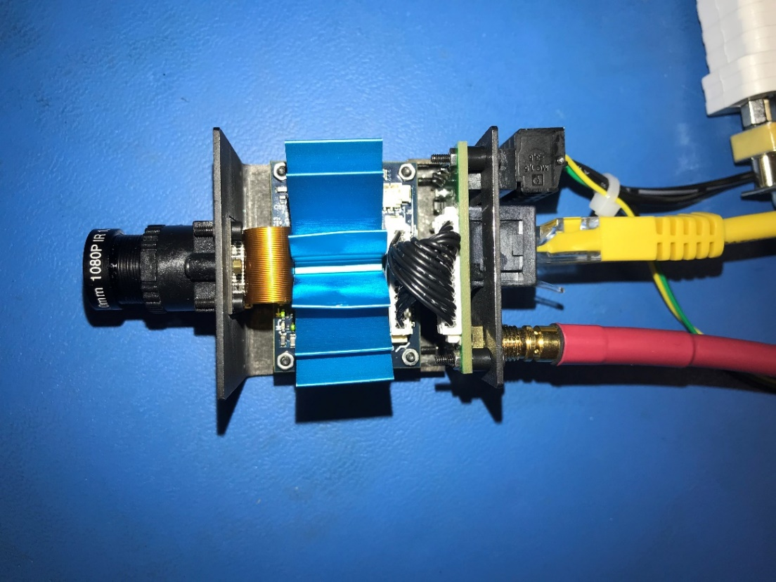

Fig 2. Assembled SLA hardware. Those external cables are: Ethernet, Analog out, and 5V power.

**The hardware has been tested successfully.**

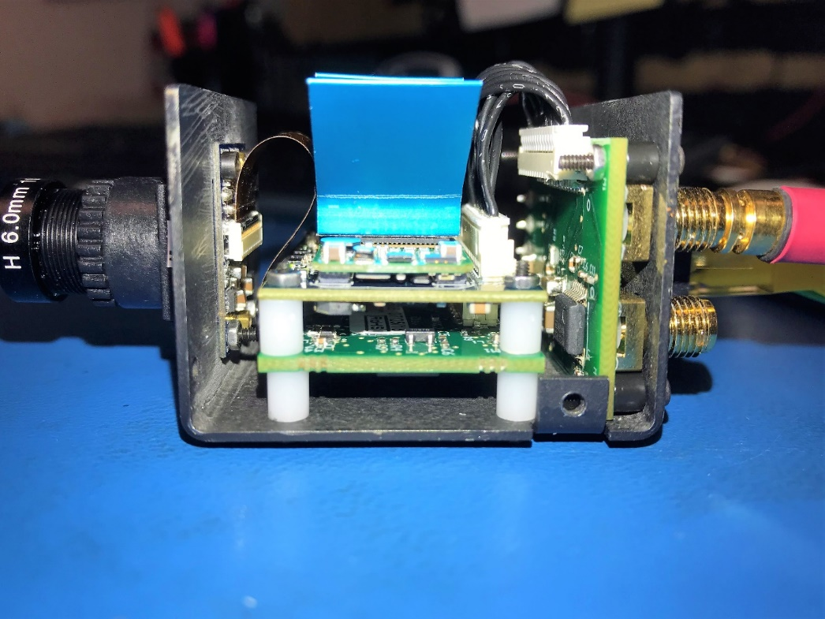

Fig 3. Assembled SLA hardware

**Pixhawk 4 Initial set up (Tai)**

Pixhawk 4 is powered from USB cable.

Issue 1: My laptop, ASUS windows 10, can’t recognize the device, Pixhawk 4. I uninstalled the software (Qgroundcontrol, PX4 driver) and installed again. It still didn’t work. The problem might come from the USB port from my laptop.

**Temporary solution:** I used Sightline’s computer to install Qgroundcontrol and PX4 driver. Yes, it works normally. The Sightline’s computer is Windows 10 pro.

**Open Qgroundcontrol:** Those initial set up and calibrate are done in Qgroundcontrol interface.

Pixhawk 4 fimware: updated to latest version.

Airframe: Calibrated

Sensor: Calibrated

**Radio:**

Error: “Detected 0 Radio Channels. To operate PX4, you need at least 5 channels.”

The Radio receiver port in Pixhawk 4: “DSM/SBUS RC 5 pin”

Tried “PPM RC” port in Pixhawk 4 -> didn’t work.

Tried a several ways to connect between Pixhawk 4 and X4R. (X4R is transmitter which is connected wirelessly to Radio Control). I haven’t figured out the problem. Plan to debug with Jeremy on Wednesday 01/30/2019

**Airframe: Quadcopter DJI Flame Wheel F450 Assembly (Kimball)**

The assembly instructions from the  [DJI F450 user manual](http://dl.djicdn.com/downloads/flamewheel/en/F450_User_Manual_v2.2_en.pdf) were more of an assembly diagram.

The following shows step by step how the F450 frame was assembled for the project.

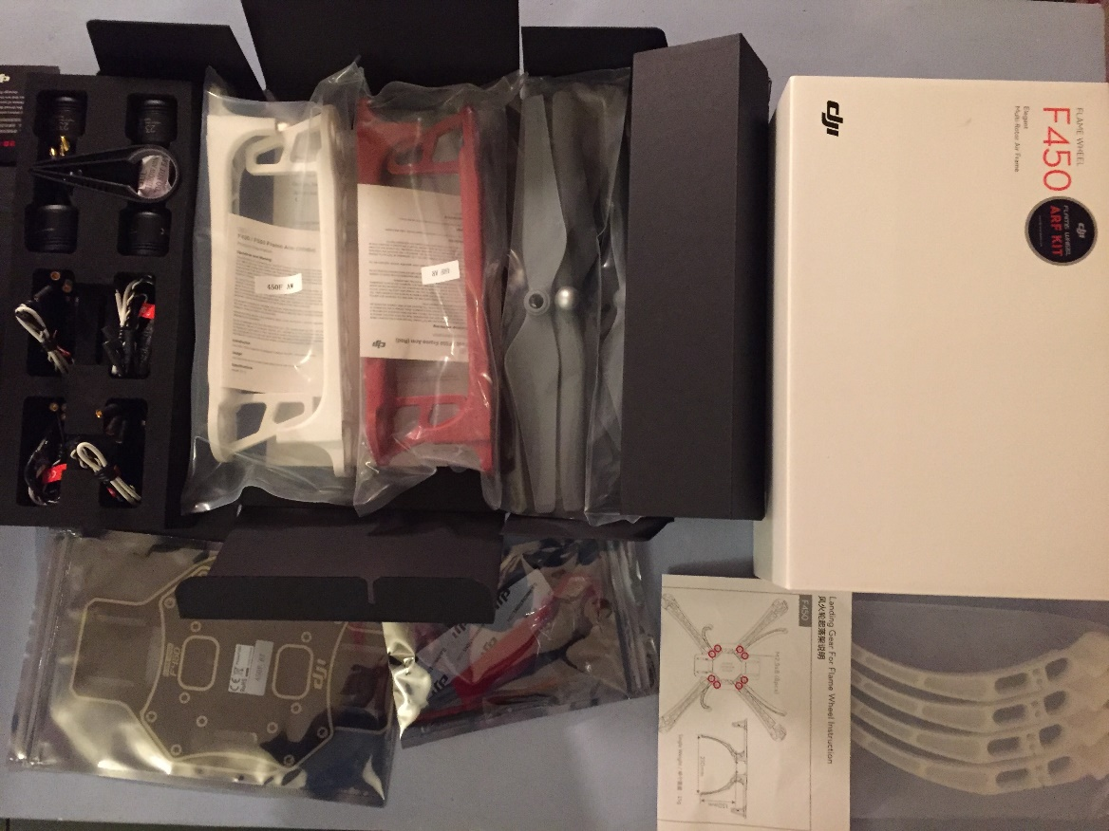

Figure 1 DJI F450 kit

In the kit there are 2 clockwise motors and 2 counter clockwise motors. The CW motors have a dimple on the rotor shaft the CCW motors do not as shown below.

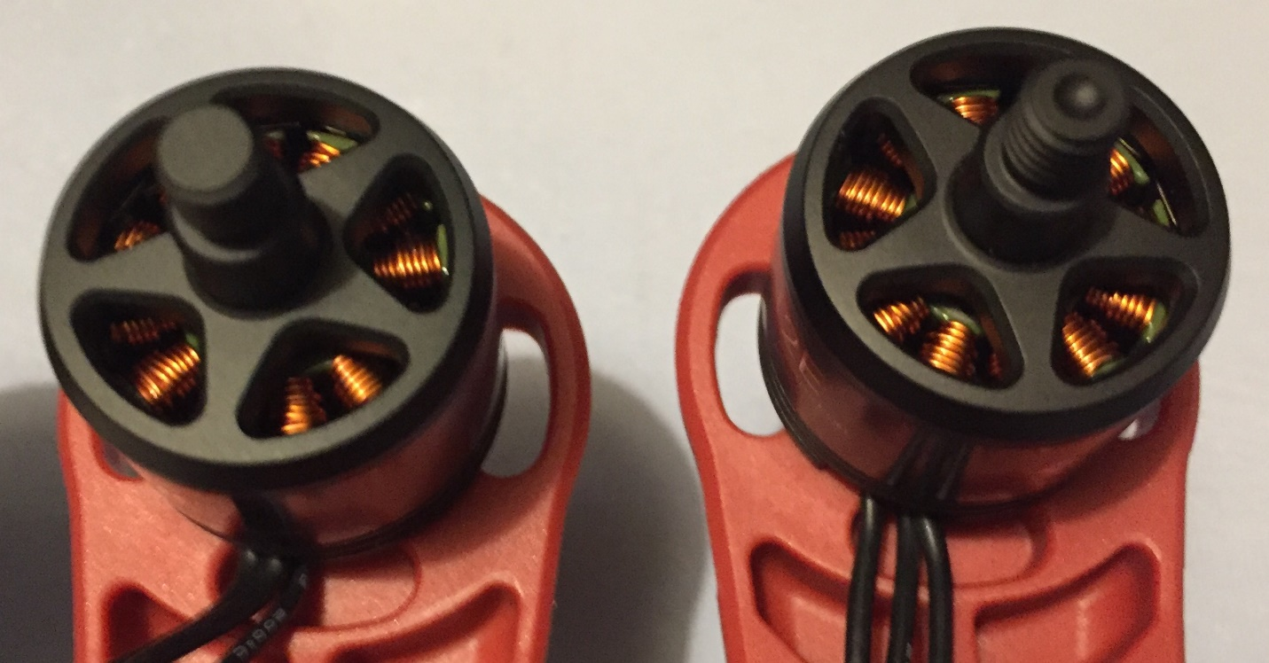

The motors were attached to the arms with the screws provided with the motors oriented according to the user manual.

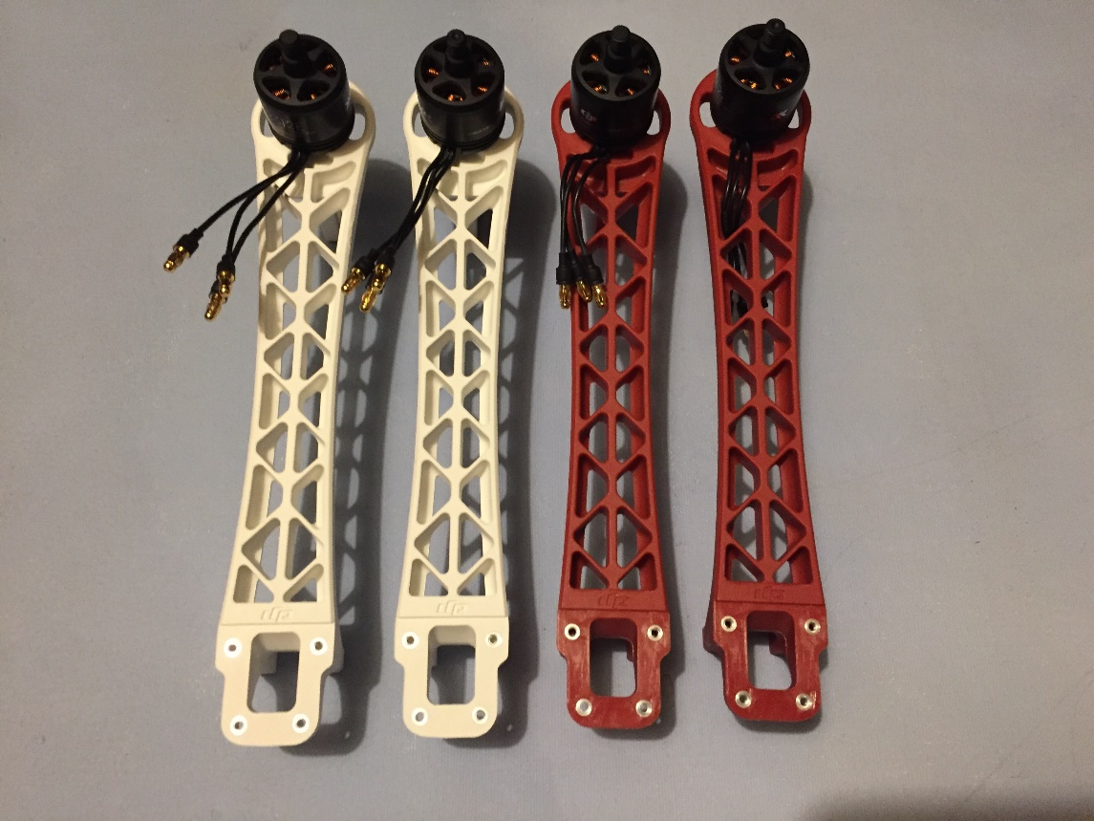

The ESC length was measured to get rid of any additional slack

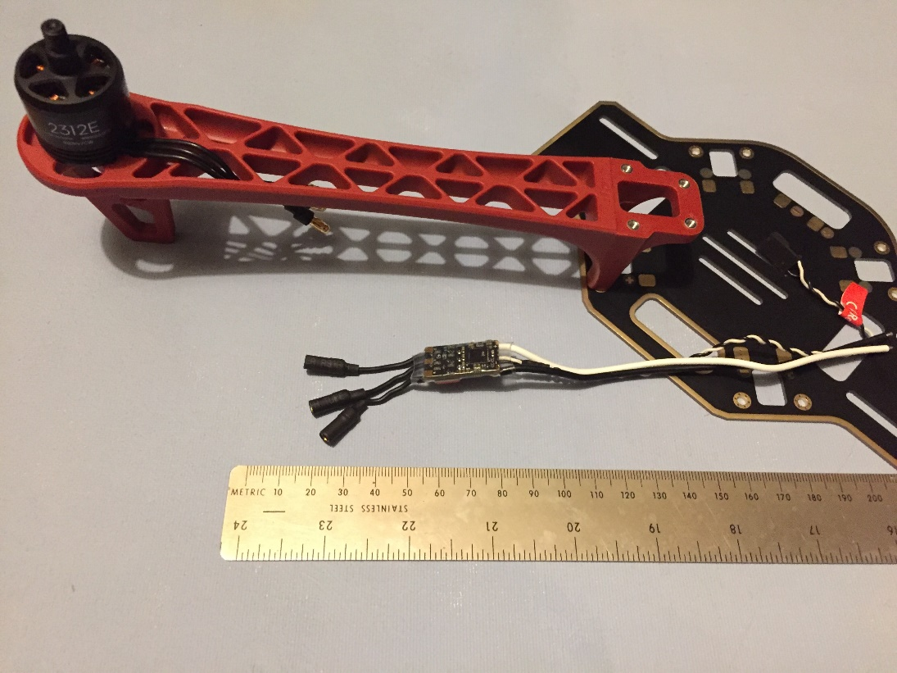

The ESC wires were cut to length then soldered to the base plate.

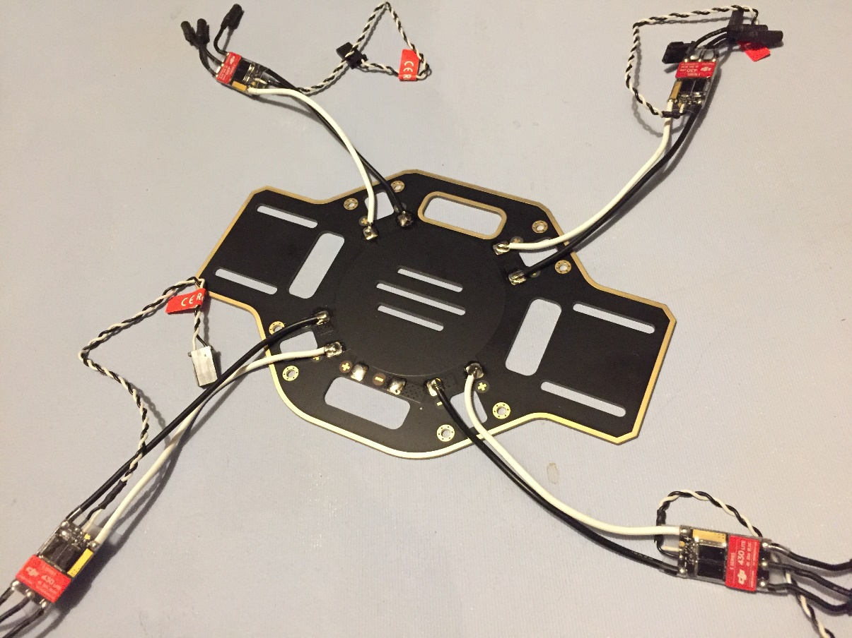

Insulating tape was applied over the solder joints.

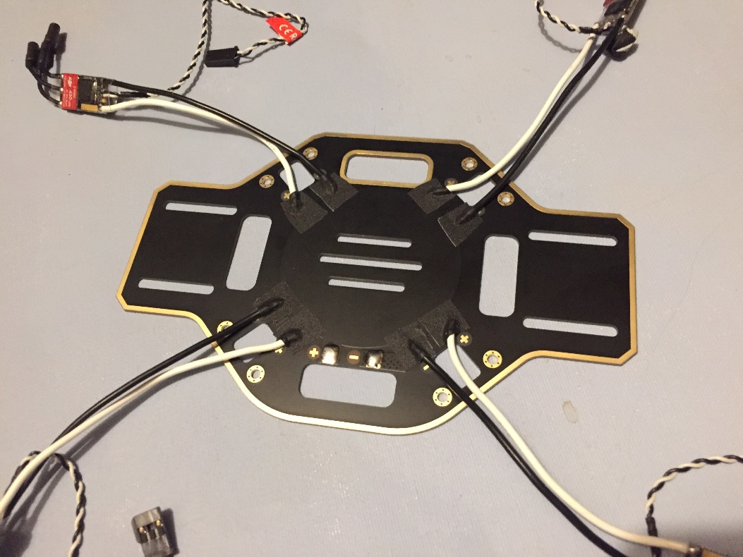

The base plate was flipped over onto one of the red arms, again the motor orientation from the user manual was observed. The arm shown has a CW motor attached.

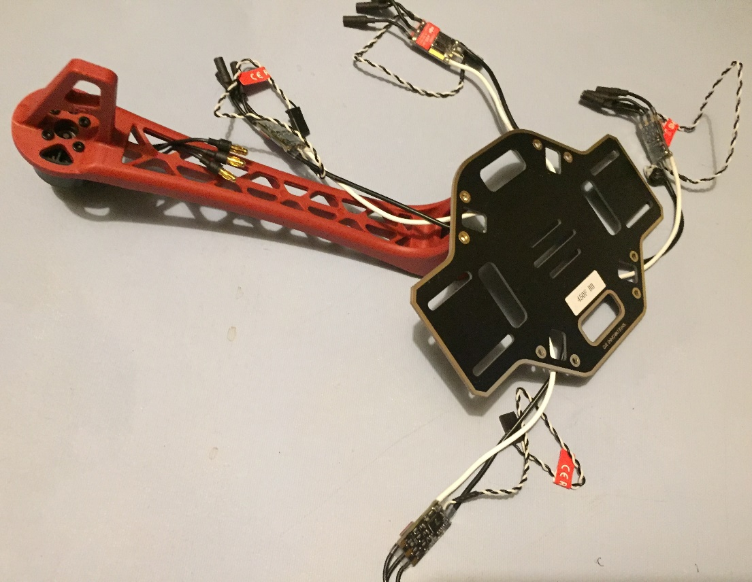

The landing gear and the frame arms are attached to each other with two screws through the base plate.

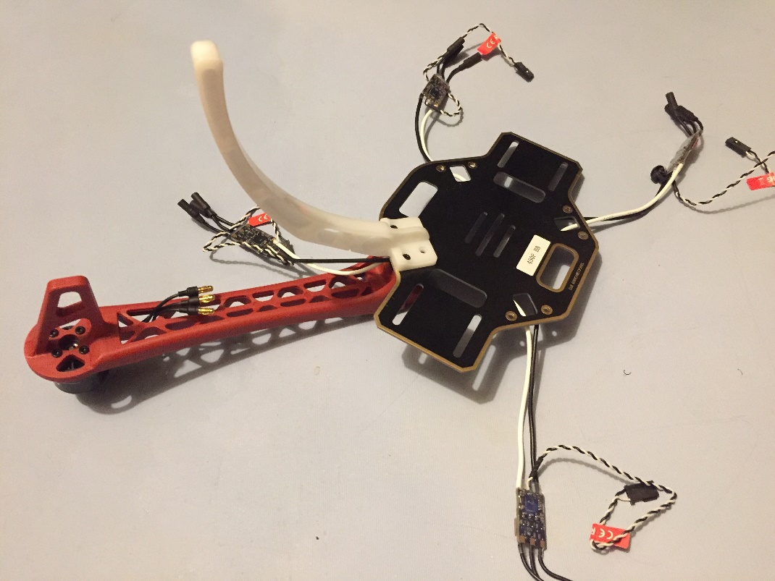

The process was repeated for the remaining three sets of arms and landing gear making shows to orient the CW and CCW motors according to the user manual.

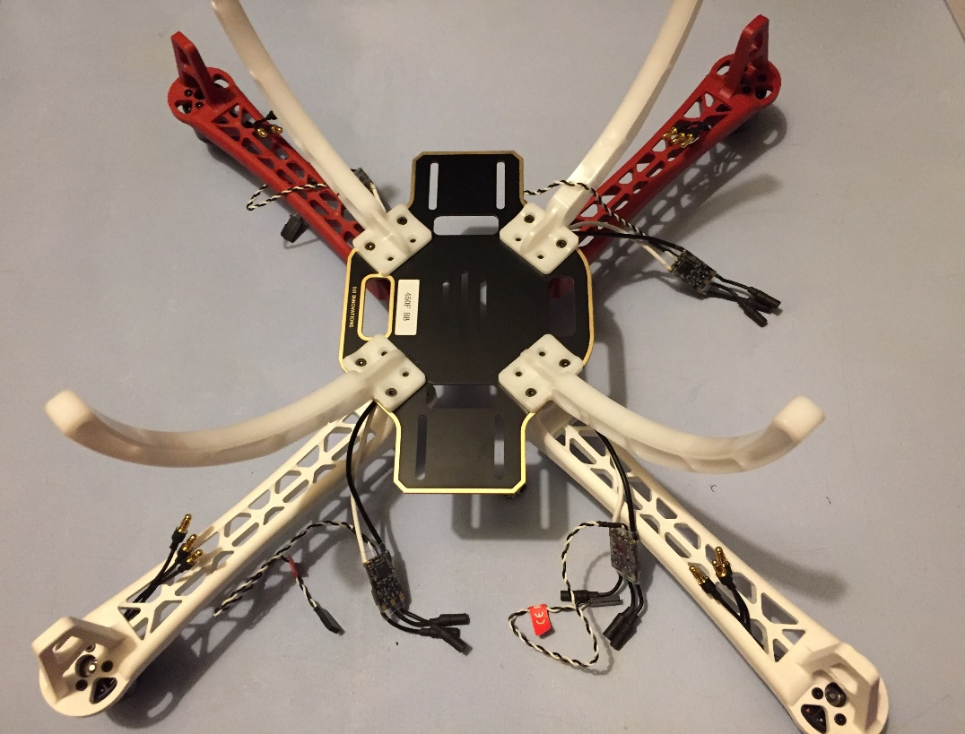

The ESC’s were connected to the motors and the wires secured to the frame with zip ties as shown below.

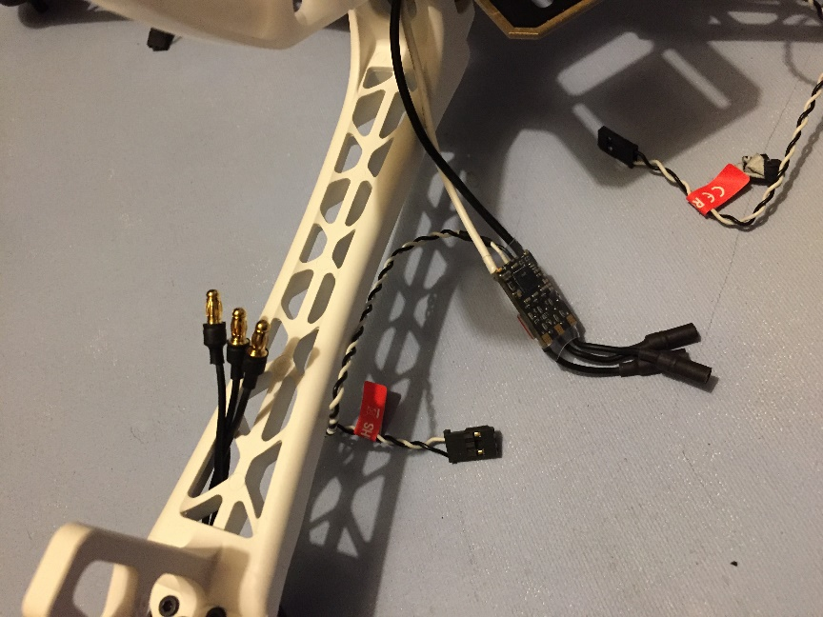 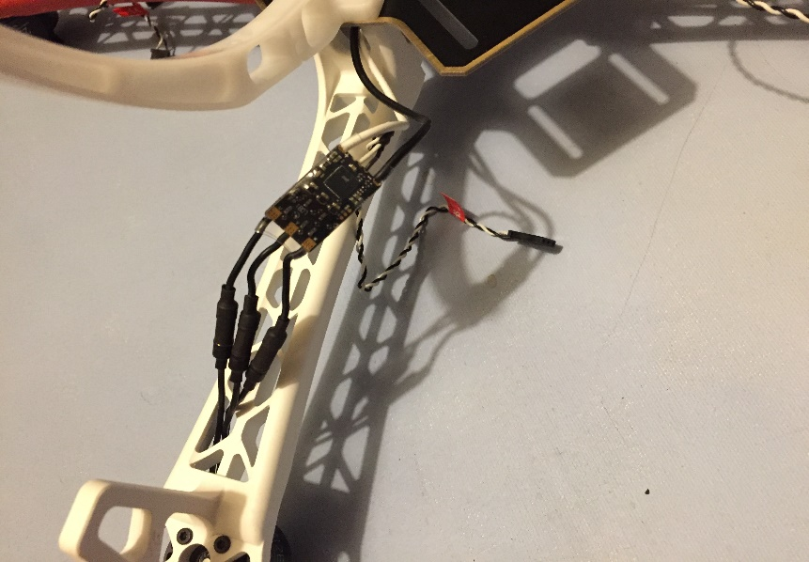

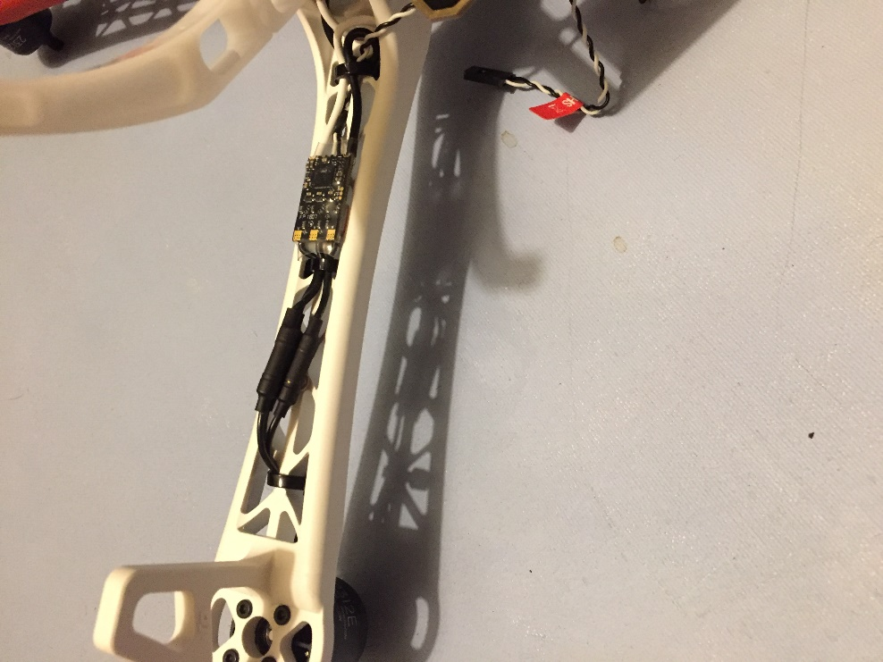

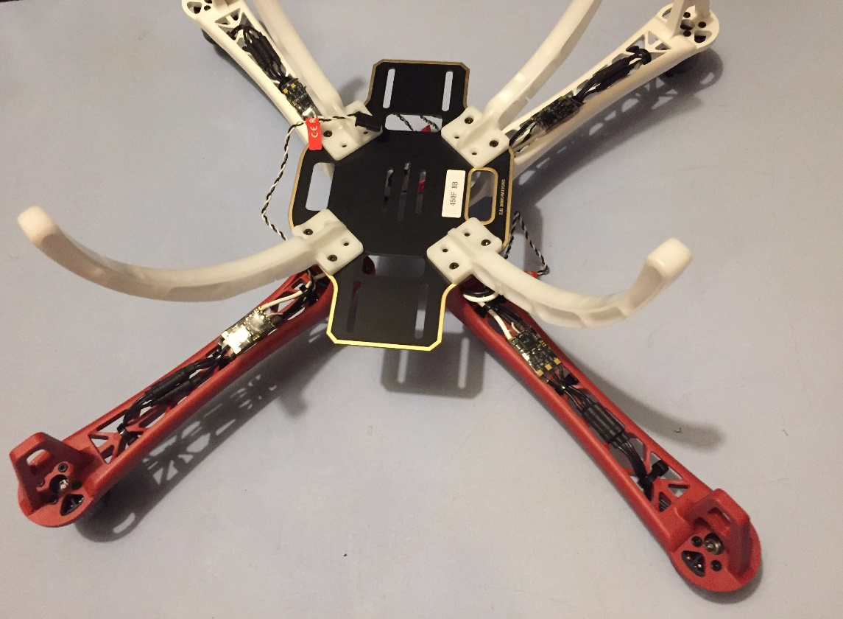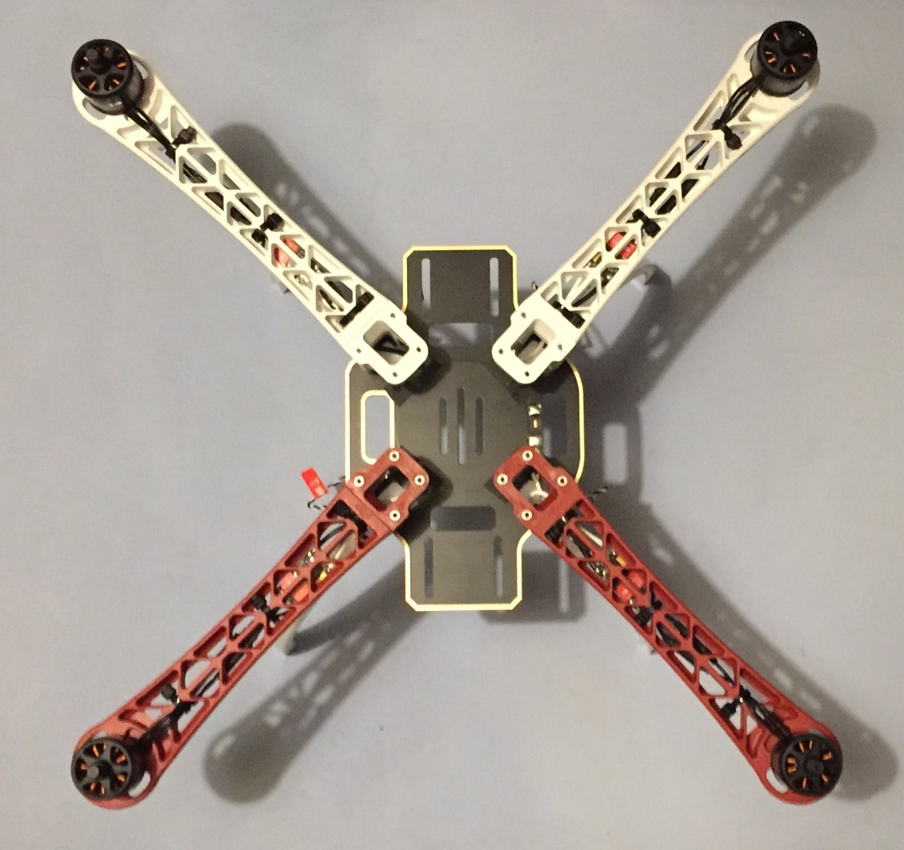

The top frame plate was then attached.

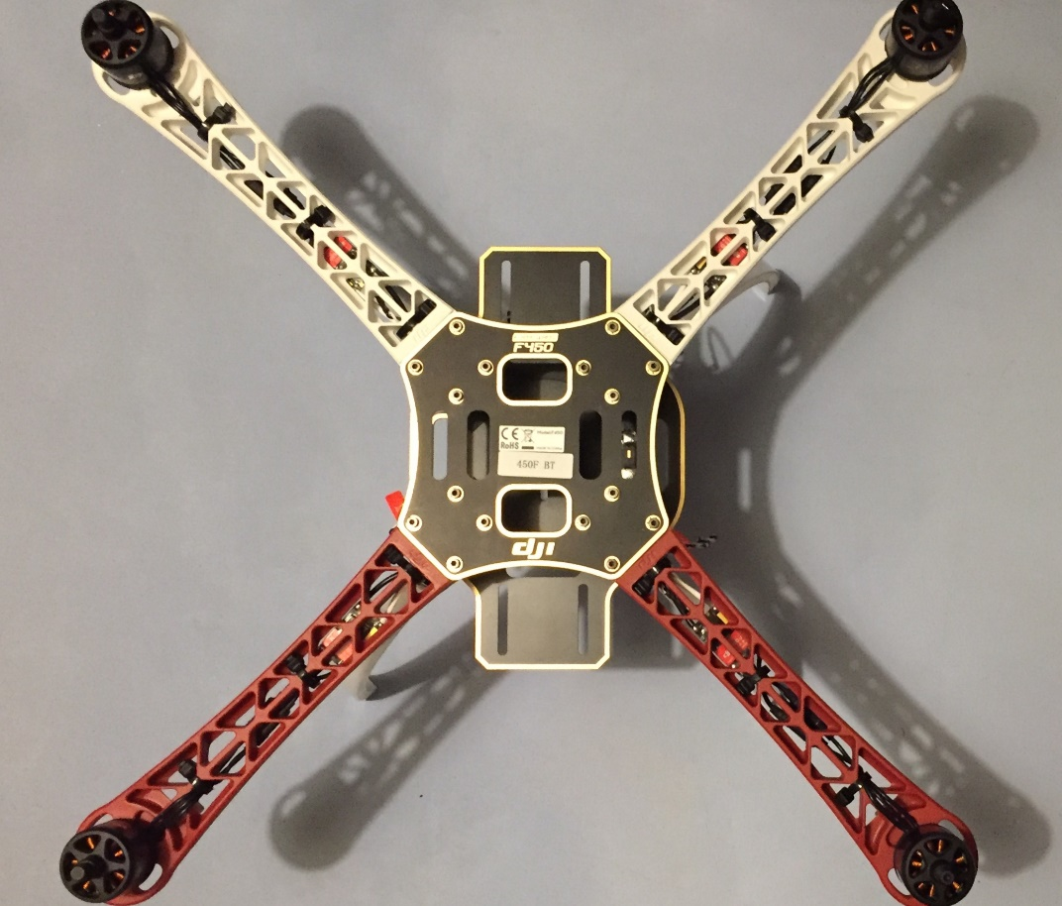

Then the propellers.

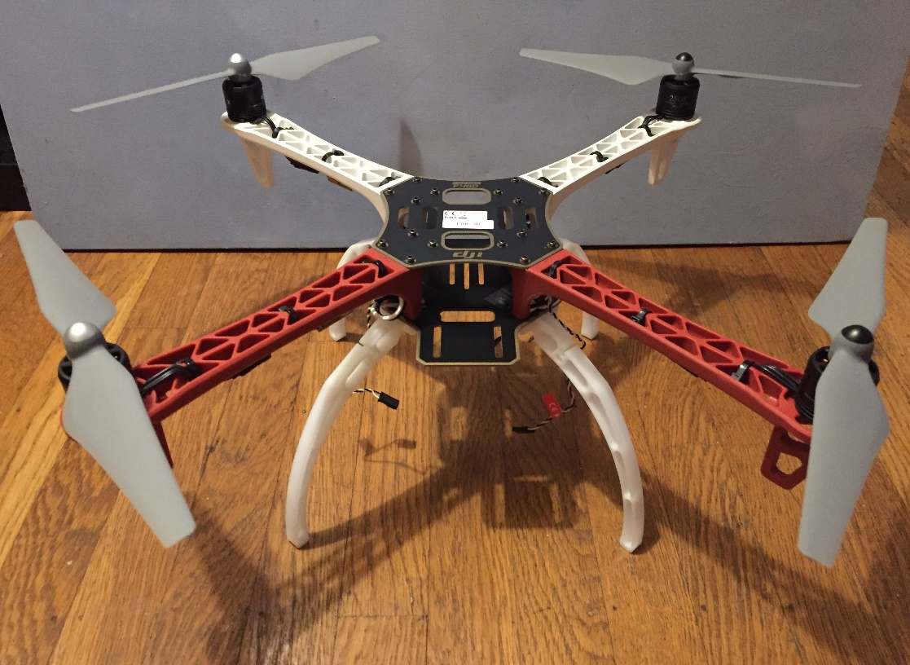

**SOFTWARE**

**.**

**.**

**.**